**Practical: 1**

**Aim: Web Service Implementation.**

**Web Service:** A Web service is any [software](https://www.webopedia.com/definitions/software/), [application](https://www.webopedia.com/definitions/application-software/) or [cloud technology](https://www.webopedia.com/definitions/cloud-computing/) system built for interoperable machine-to-machine or application-to-application interaction over a network. They allow different applications to seamlessly communicate and share data with each other.

1. First create java web application project.

Go to File>New Project

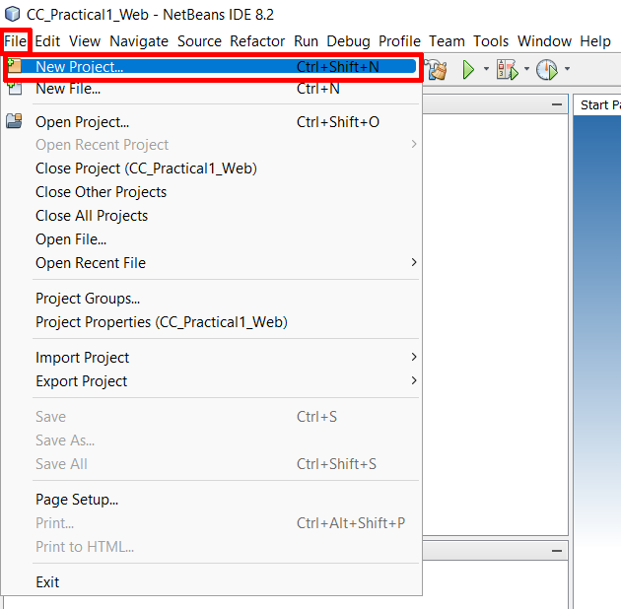

1. On right hand side list select “Java Web” Categories and on left hand side list select “Web Application” and then click “Next”

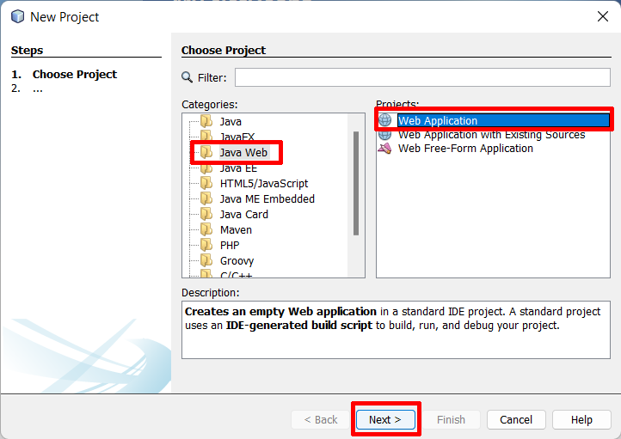

1. Enter name of your project in “Project Name” field and click next.

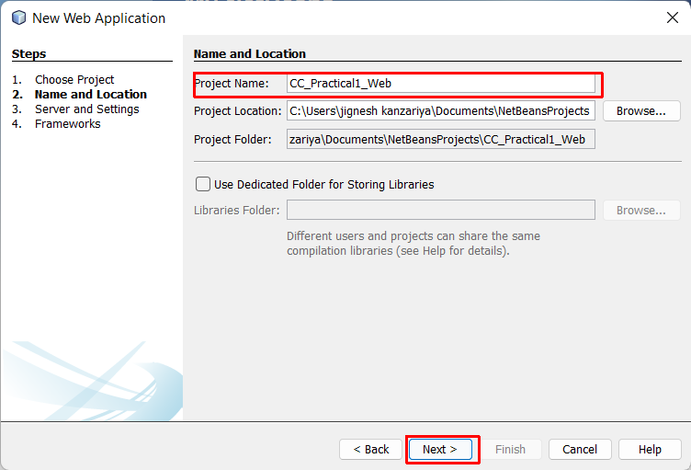

1. Select Server:- “GlassFish Server 4.1.1”. Select Java EE Version:- “Java EE 7 Web” then click “Finish” button.

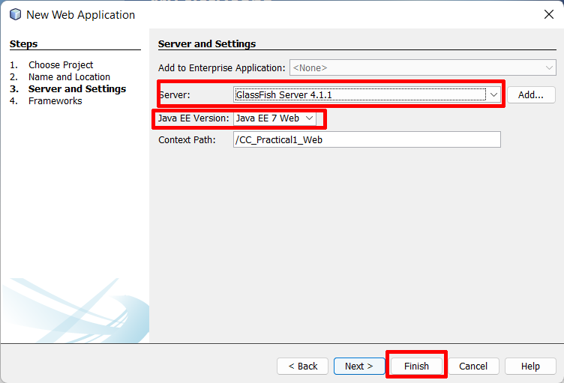

1. After that “Add Java Package”. On right side “Projects” tab you can see your project. Right Click on your project go to New > Java Package.

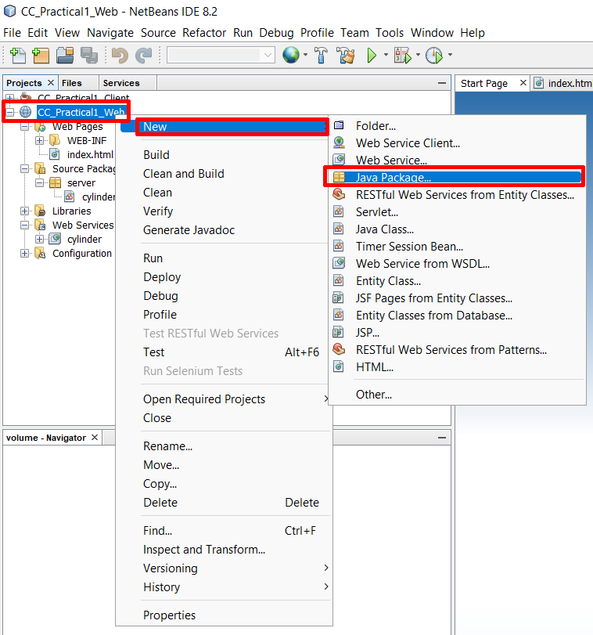

1. Add Java Package Name and click “Finish” button.

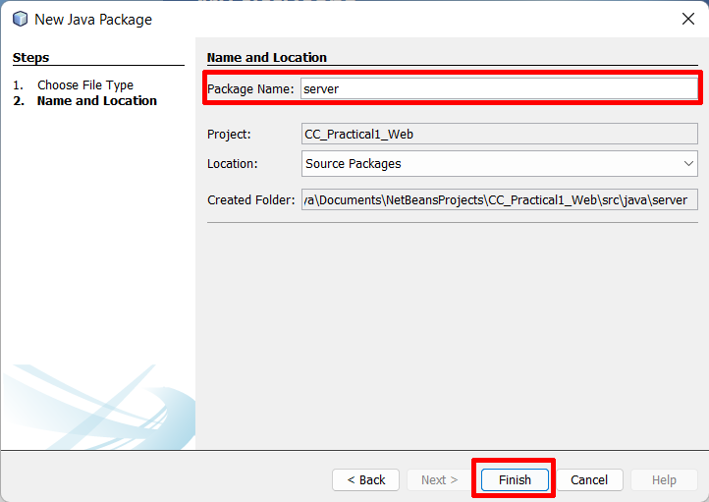

1. Create Web Service.

[your web project name] > Source Packages > [your package name] > Right Click > New > Web Service.

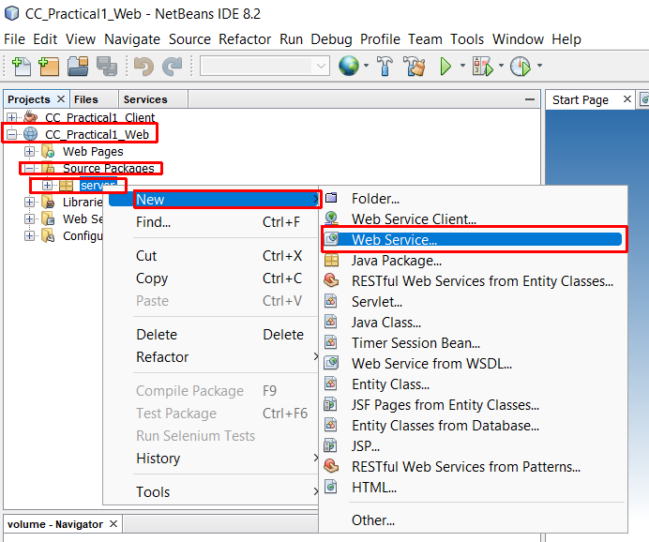

1. Add Web Service Name then click on “Finish”.

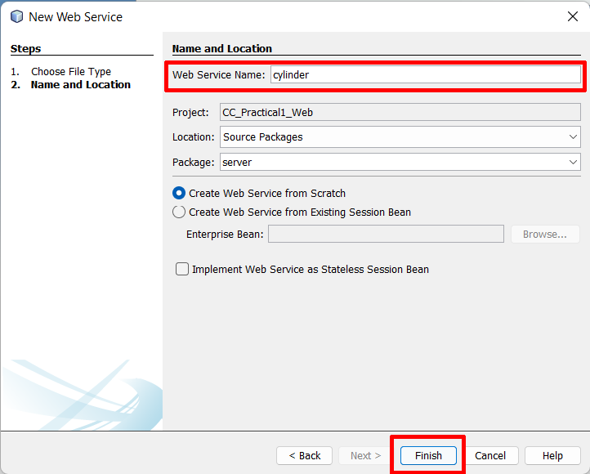

1. Add an operation inside the web service that you have created before.

[your web project name] > Web Services > [your web service name] > Right Click > Add Operation.

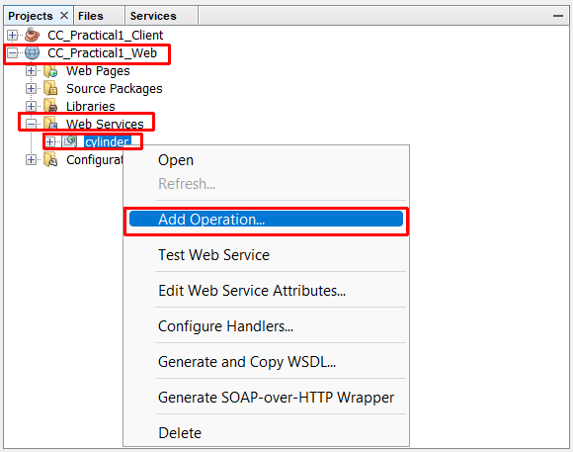

1. Add your Operation.

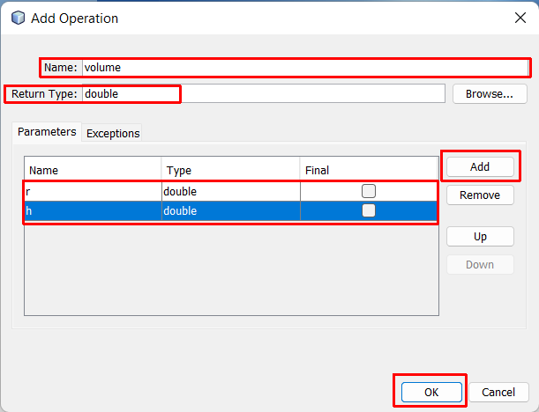

1. Modify your web service Java file as per your requirements.

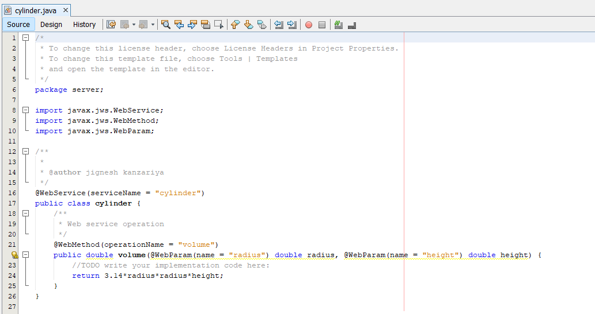

1. Deploy your Project.

[your web project name] > Right Click > Deploy.

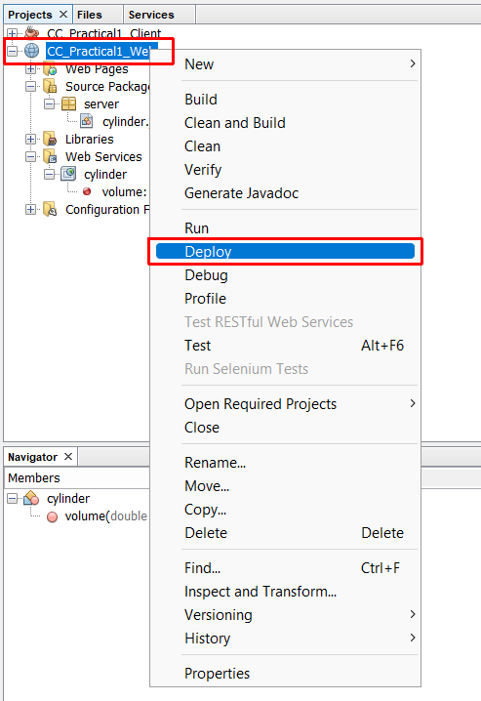

Output.

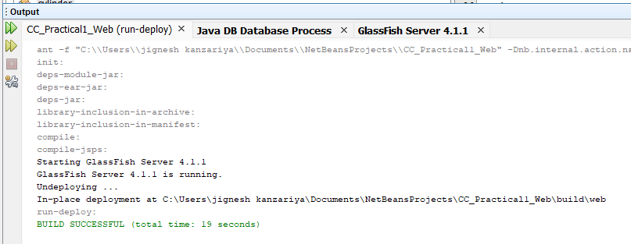

1. After that Test Web Service.

[your web project name] > Web Services > [your service name] > Right Click > Test Web Service.

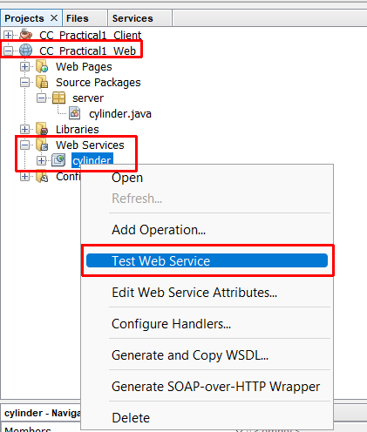

1. After clicking "Test Web Service," the browser will open and you will be able to see your operation. Check to see if it is working or not. by applying input and resulting output.

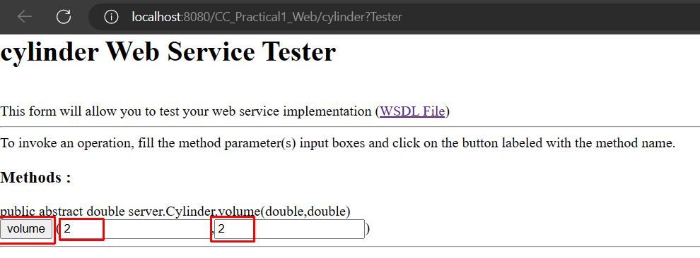

Output:

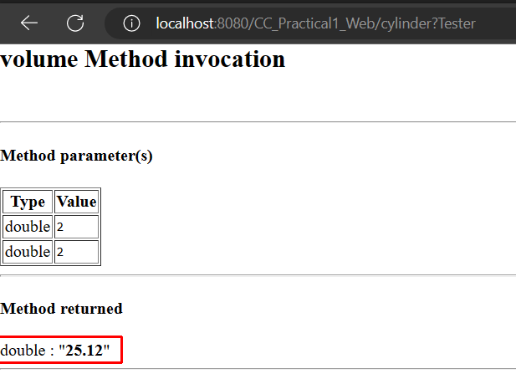

1. Now it's time to create a client after testing your web service on a browser. For that, you need a WSDL file. So, click on the WSDL file link and copy the URL of WSDF file.

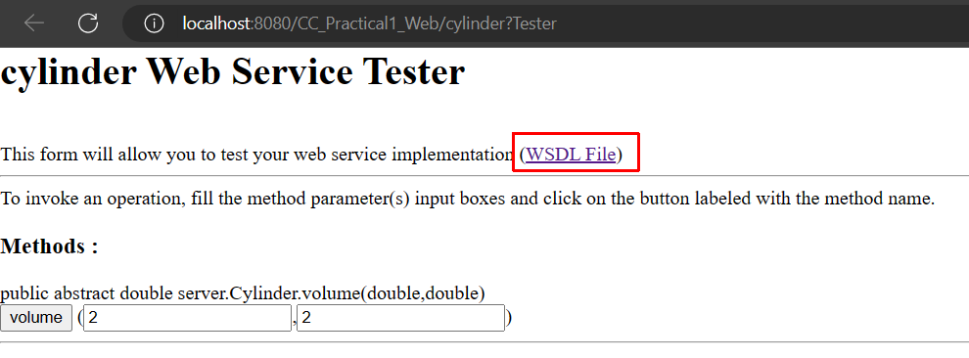

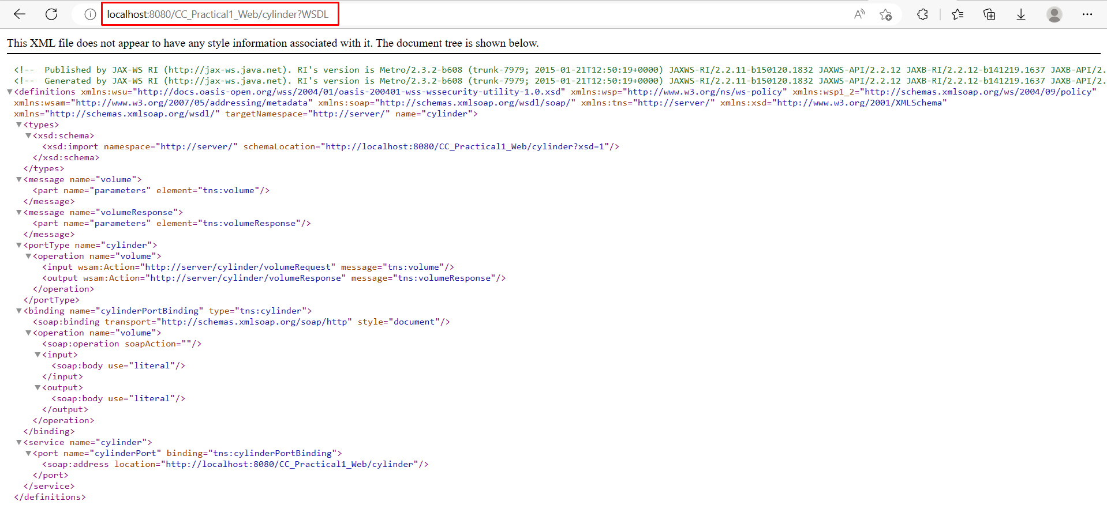

1. Now create java application it is work as client of our web application.

File > New Project.

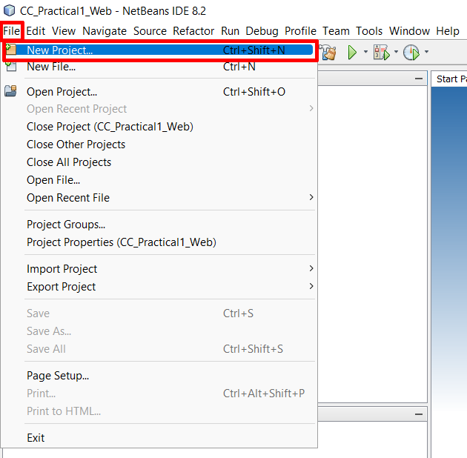

1. Enter your java project name and click “Finish”.

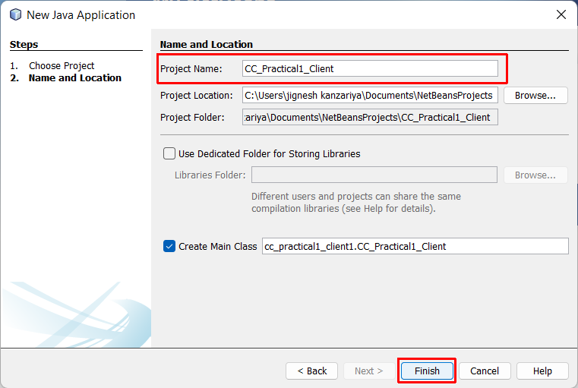

1. Add Web Service Client in your java application project.

[your java project] > Right Click > New > Web Service Client.

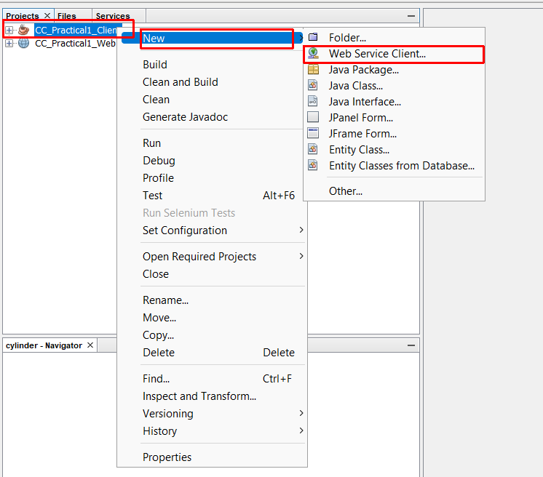

1. In the Web Service Client window, select the WSDL URL. Paste a previously copied WSDL URL into an inside WSDL URL field.

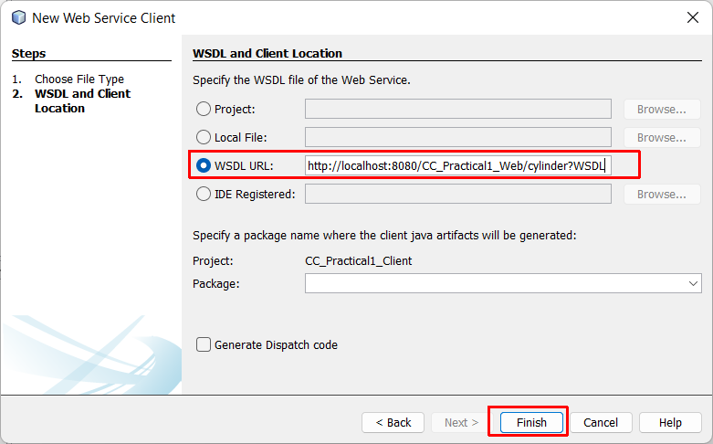

1. Insert Code of web service in java application project for that you need to open java file.

[your java project name] > Source Packages > [project name] > [project name].java.

Inside java file Right Click > Insert Code.

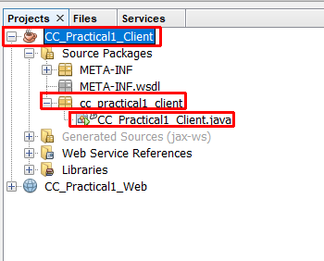

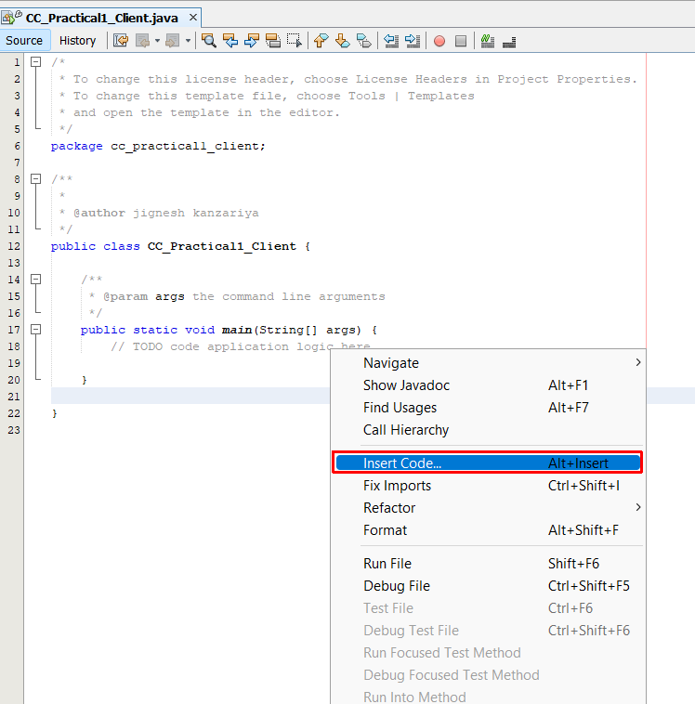

1. After that click “Call Web Service Operation”.

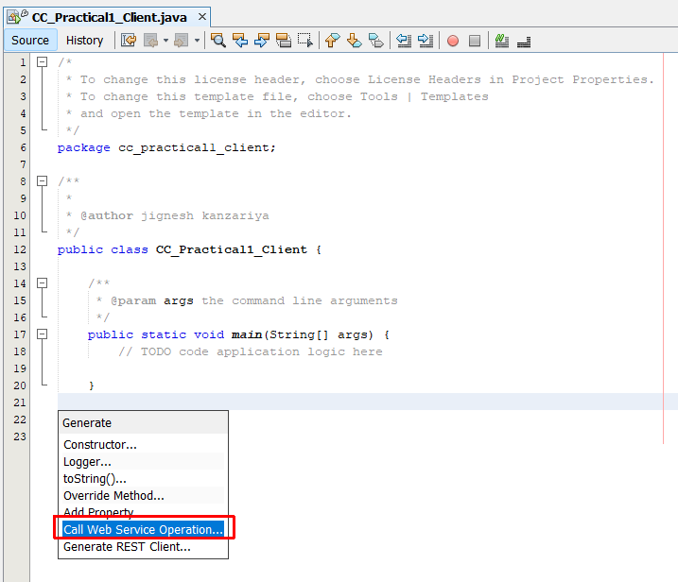

1. Select the operation you want to insert.

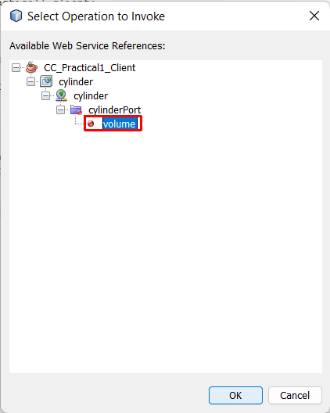

1. Modify code as per need.

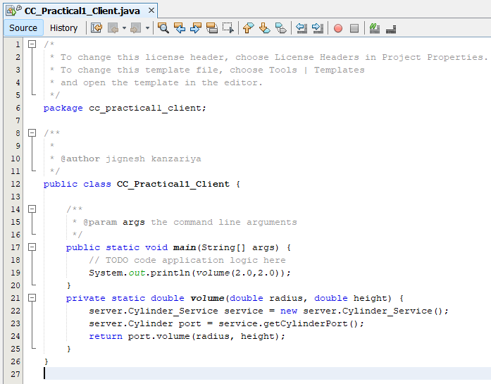

1. Run the file and see output that comes from the server.

